**SAMPLE MFB – LOAN SYSTEM ARCHITECTURE**

This document describes the intended flow of the proposed system.

|  |  |
| --- | --- |
| **SYSTEM REQUIREMENTS** | |
| Design & Development Framework | DotNet/Java (Spring)/ Angular |
| Hardware Requirements (Minimum) | Core i5, 1.8 GHz, 4 gig RAM, 32gig disk space. |
| Hardware Requirements (Recommended) | Core i5, 2.5 GHz GHz, 8/16 gig RAM, 500 gig disk space. |
| Operating System | Windows 10, Mac OS |
| Network and Security | High level privileges required. |
| Application Server | IIS/Oracle Weblogic / Tomcat Server (platform-dependent) |
| Internet Access | High speed internet access. |
| Software Requirements | All free downloadable tools. |
| Data Storage | Local Storage Server  Online Storage. |

APPLICATION FLOW

1. 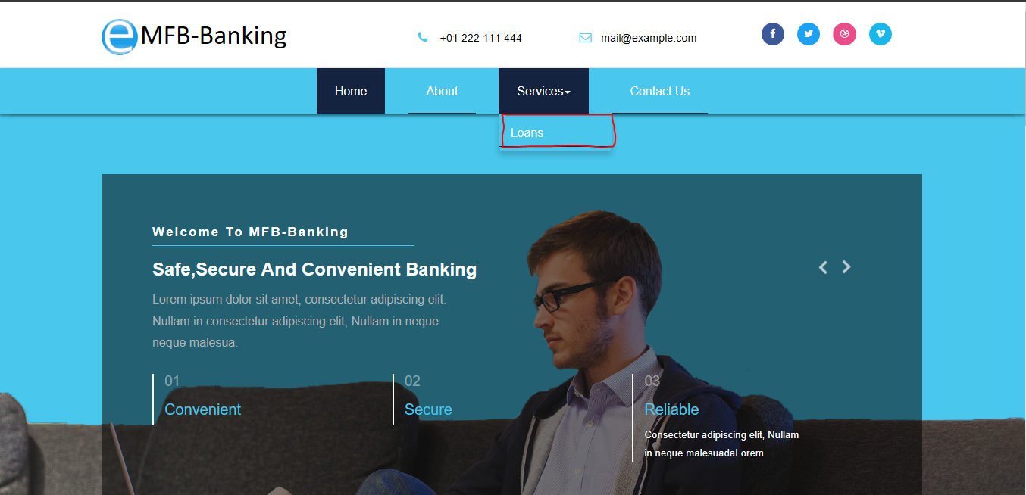The link to the loan form application is made available only over the internet-banking and mobile banking platforms. Can either be a navigation link or a text link.
2. On click of the link, a token is generated based on security framework protocol to authenticate the link and allow access to the platform.

NB: The loan application is only available via the above mentioned two platforms and not accessible by any third party over the internet unless allowed in future date.

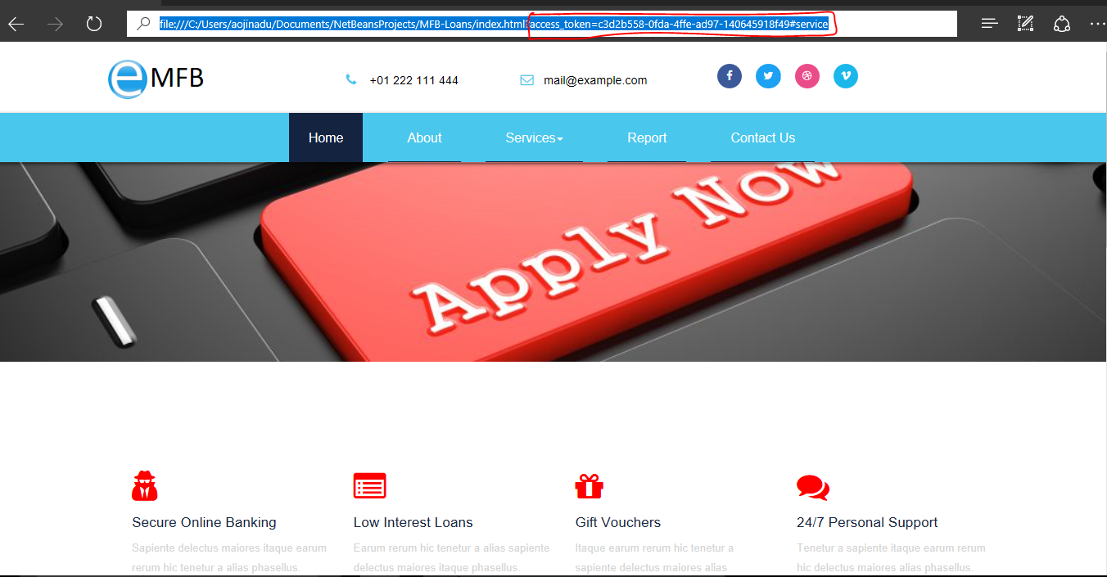

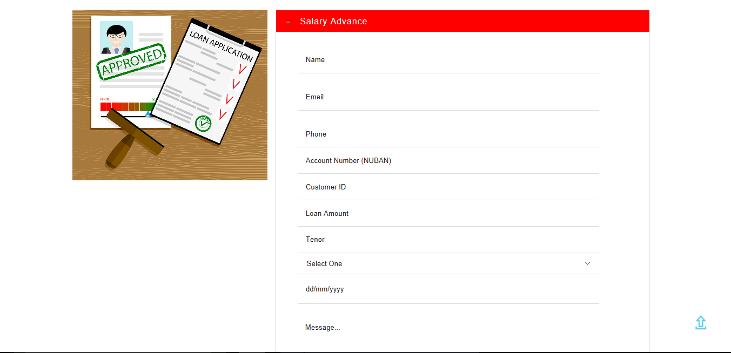

1. The reporting platform is only accessible to privileged member of staff, logged in with allowed username and password and with ADMIN role.

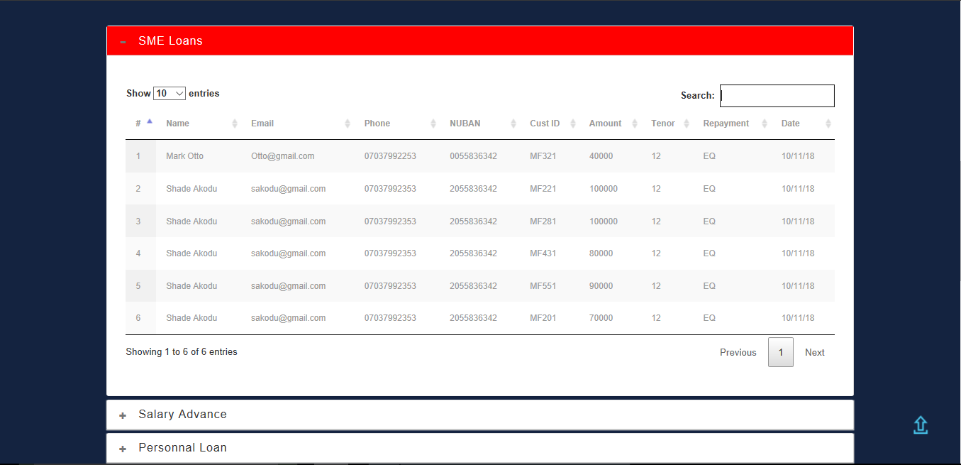

Further information on the application architecture and dependencies will be made available in due course.